**ANALYZE DATA IN A MODEL CAR DATABASE WITH MYSQL WORKBENCH**

**Project scenario:**

Mint Classics Company, a retailer of classic model cars and other vehicles, is looking at closing one of their storage facilities.

To support a data-based business decision, they are looking for suggestions and recommendations for reorganizing or reducing inventory, while still maintaining timely service to their customers. For example, they would like to be able to ship a product to a customer within 24 hours of the order being placed.

**Skills demonstrated:**

* Imported an existing database using MySQL Workbench.
* Familiarized with a business and its data by reviewing a relational model diagram and exploring tables of data in MySQL Workbench.
* Analyzed inventory data using SQL queries in MySQL Workbench that retrieve data from a multiple-table relational database using SQL commands such as: select, order by, where, group by, and having.
* Developed recommendations and suggestions for solving a business need/problem based on data analysis.
* Recommendations and suggestions for inventory reduction in the form of scripted queries.

**Tools used:**

MySQL Workbench, SQL queries, Mint classics database file.

**Conclusion:**

* We can reduce the products whose estimated prices are low .
* We can reduce the productline train which has the lowest sales from 2003-2005.
* Trains product line has the minimum number of products which is 3.
* In my opinion, there is no need to close warehouse.

**Solution:**

**Q1. Which countries are the customers of Mint classics located in ?**

*select distinct country from customers;*

**List of countries where customers are located(27 in total).**

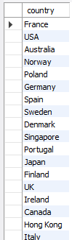

**Q2. Which country has the highest number of orders between 2003 and 2005?**

*select country, count(country) as countC*

*from orders o*

*join customers c*

*on o.customerNumber = c.customerNumber*

*group by country*

*order by countC desc;*

**The USA topped the list with 112 oders from 2003 to 2005.**

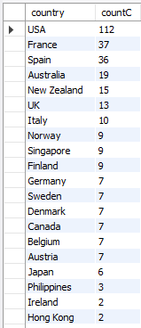

**Q3.** **What is the hierarchy of the company’s employees and how can an organizational chart be generated?**

***select e.employeeNumber,***

***concat(e.firstName,' ',e.lastName) as Employee_Name,***

***concat(s.firstName,' ',s.lastName) as Supervisor_Name***

***from employees e***

***join employees s***

***on e.reportsTo = s.employeeNumber;***

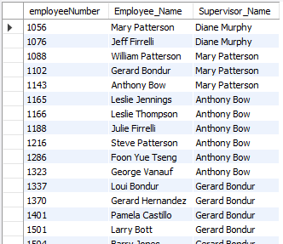

**Q4. What countries are the company branches situated in and which employee(s) work there?**

***select e.employeeNumber, e.firstName, e.lastName, e.jobTitle,***

***o.city,o.addressLine1 as address, o.state, o.country***

***from employees e***

***join offices o***

***on e.officeCode = o.officeCode***

***order by employeeNumber;***

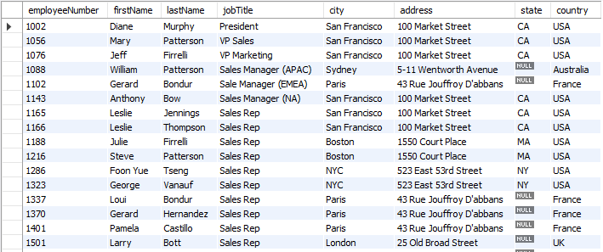

**List of employees, city, state , country and address of where they work.**

**Q5: What are the list of orders that have been shipped successfully from 2003–2005?**

***select orderNumber, customerNumber, shippedDate, status***

***from orders***

***where status = "Shipped"***

***order by customerNumber;***

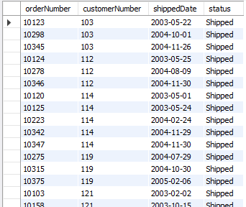

**List of orders shipped from 2003 to 2005.**

**Q6: What is the total number of products/orders that have been shipped from 2003–2005?**

***select count(status) as totalShipped***

***from orders***

***where status = "Shipped";***

**Q6.PNG**

**Total number of shipped products from 2003 to 2005.**

**Q7: Taking the orders of customers into context, what product(s) did they actually request for?**

***select od.productCode, od.orderNumber,***

***o.orderDate, od.quantityOrdered,***

***od.priceEach, p.productName, p.productLine***

***from orderdetails od***

***join products p***

***using(productCode)***

***join orders o***

***using(orderNumber)***

***order by orderNumber;***

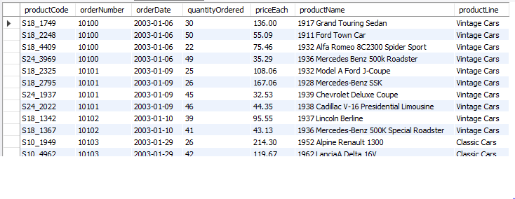

**List of Orders from customers**

**Q8: What is the list of total sales, the total amount of sales and the total number of sales for the year 2003?**

* **List of total sales**

***select customerNumber,***

***paymentDate, amount***

***from payments***

***where paymentDate <= '2003-12-31';***

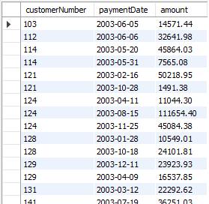

* **Total amount of sales**

***select sum(amount) as totalSum***

***from payments***

***where paymentDate <= '2003-12-31';***

**Q8B.PNG**

* **Total number of sales**

***select count(customerNumber) as number_of_payments***

***from payments***

***where paymentDate <= '2003-12-31';***

**Q8C.PNG**

**Q9: What is the list of total sales, the total amount of sales and the total number of sales for the year 2004?**

* **List of total sales**

***select customerNumber, paymentDate, amount***

***from payments***

***where paymentDate between '2004-01-01' and '2004-12-31';***

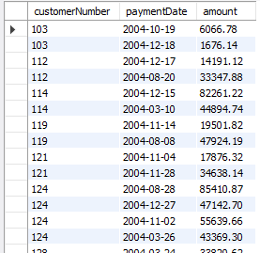

* **Total amount of sales**

*select sum(amount) as totalSum*

*from payments*

*where paymentDate between '2004-01-01' and '2004-12-31';*

**Q9B.PNG**

* **Total number of sales**

*select count(customerNumber) as number_of_payments*

*from payments*

*where paymentDate between '2004-01-01' and '2004-12-31';*

**Q9C.PNG**

**Q10: What is the list of total sales, the total amount of sales and the total number of sales for the year 2005?**

* **List of total sales**

*select customerNumber, paymentDate, amount*

*from payments*

*where paymentDate between '2005-01-01' and '2005-12-31';*

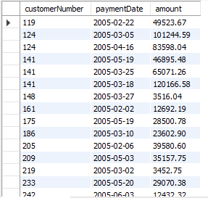

* **Total amount of sales**

***select sum(amount) as totalSum***

***from payments***

***where paymentDate between '2005-01-01' and '2005-12-31';***

**Q10B.PNG**

* **Total number of sales**

***select count(customerNumber) as number_of_payments***

***from payments***

***where paymentDate between '2005-01-01' and '2005-12-31';***

**Q10C.PNG**

**Q11: What products are currently in stock, purchase price, sale price and estimated profit?**

***select p.productCode, p.productName, pl.productLine, p.quantityInStock,***

***p.buyPrice as purchasePrice, p.MSRP as salePrice,***

***(p.MSRP - p.buyPrice) as estimatedProfit***

***from products p***

***join productlines pl***

***using(productLine)***

***order by productCode;***

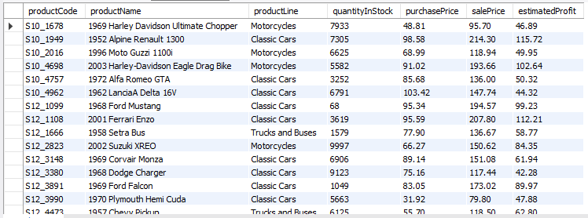

**Products in stock, purchase price, sales price and estimated price**

**Q12: What is the productline with the highest orders?**

*select p.productLine, count(od.productCode) as noOfSales*

*from products p*

*join orderdetails od*

*on p.productCode = od.productCode*

*group by p.productLine*

*order by noOfSales desc;*

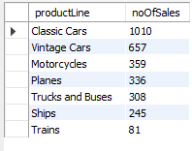

**Summary:**

* The customers of**Mint classic company** are located in **27 countries.**
* The **U.S.A** has the highest number of orders totaled to **112**, followed by **France (37)** and **Spain (36)**
* The hierarchy of organizational power **(employees and their supervisors)**
* List of *employees*,*city*, *state*,*country* and *address* where they work (company branch)
* List of orders shipped from **2003-2005 (303 in total)**
* Most sales by *productline*with **classic cars**topping the list **(1010 in total)**
* Most sales were made in **2004** with **$4,313,328.25** and **136** by count
* The least sales were made in **2005** with only **$1,290,293.28** and **37** by count
* Total sales recorded from **2003–2005** were **$8,853,839.23.**

**------------------**